**1- Introduction**

Digital Elevation Models (DEMs) are widely used in automated stream network extraction. Numerous techniques have been proposed to extract the stream network from DEM represented either in the form of a Triangular Irregular Network (TIN), or as a regular raster surface. Assuming that water always flows along the path of steepest descent, DEM-based methods simulate the flow of water and track its flow to eventually delineate stream networks.

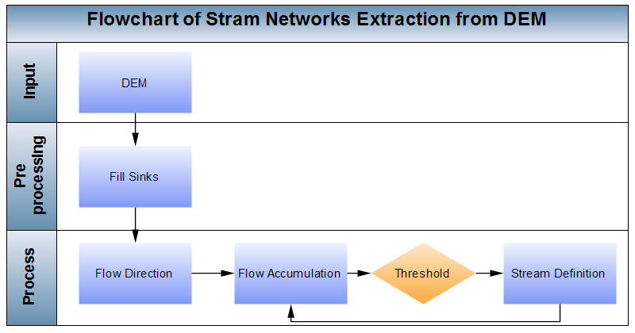Figure 1 illustrates stream network extraction from raster DEM. For stream definition a threshold for flow accumulation is defined; all cells in the flow accumulation matrix with a value greater than the threshold are defined as a stream cell and assigned the value “1” in the stream matrix. All other cells are assigned the value of "0". A lower threshold value results in a denser stream network. The procedure is as follows:

Fig. 1. The flowchart of stream network extraction form DEM

* **Fill sinks:** A sink is a cell surrounded by higher elevation cells, in which the water is trapped and cannot flow. The fill sinks function raises the elevation of the sinks to be consistent with their neighboring cells.
* **Flow direction:** This function produces a so-called flow direction matrix whose cells indicate the direction of flow from each grid cell to its downhill neighbor. Among the eight neighbors of each cell, the one with the steepest descent is selected (called D8 method).
* **Flow accumulation:** For each cell in the flow direction matrix, this function counts the accumulated number of upstream cells, results in the flow accumulation matrix.
* **Stream definition:** Defining a threshold for flow accumulation, all cells in the flow accumulation matrix with a value greater than the threshold are defined as a stream cell and assigned the value “1” in the stream matrix. All other cells are assigned the value of "0". A lower threshold value results in a denser stream network and more number of catchments.

The most common way to determine a stream threshold is trial and error. That is, a suitable threshold is selected based on multiple trials, followed by visual comparison of the networks generated with ancillary datasets such as topographic maps or available benchmark datasets (Figure 1). This procedure is so time consuming, and is considered one of the main challenges of stream network extraction. In this research project, an automated workflow was used to extract stream networks. A sequence of stream networks was extracted from a flow accumulation matrix using a series of thresholds. Then, to assess the results and find the optimum threshold, the extracted stream networks was compared to another data source as a benchmark (here, we use the National Hydrography Dataset (NHD) as one of the most commonly used data for hydrological analysis). “ModelBuilder” of ArcGIS software was used to create a model that iteratively ran through a series of selected thresholds, seeking the best possible threshold providing the highest accuracy value. Although this model ran successfully, the final extracted stream networks were determined inaccurate, as they did not account for density differences. That is, using one single threshold for extracting stream networks for an input DEM leads to inaccurate results due to disparities in density, and this issue is more serious for larger hydrological units.

|  |  |
| --- | --- |
|  |  |
| (a) | (b) |
| Fig. 2: Available benchmark commonly used for selecting the proper threshold: (a) Topographic maps and, (b) National Hydrographic Dataset | |

To compensate for this error, a new method is proposed. Its intention is to determine the best thresholds of the density partitions for the hydrological unit of interest. To obtain the best threshold, flow direction and flow accumulation are first derived from digital elevation models (DEMs) for the whole study area. Once the values for flow direction and accumulation are determined, the study area is categorized based on the density of river networks. Then, for each of these density partitions, the best threshold is calculated.

The rest of the report is organized as follows: Section 2 elaborates on the datasets and study areas used in the project, including Colorado, Missouri, Texas and West Virginia subbasins. In Section 3, the methodology is introduced by discussing the proposed method named density-based stream network extraction from DEM. In the next section, the proposed method is used for the abovementioned study areas, and the results are evaluated. Finally, in Section 5, the conclusions of this research will be addressed.

**2- Datasets and Study Areas**

The data required to run the model was obtained from several sources. Both of the datasets used, National Elevation Data (NED) and National Hydrologic Data (NHD), made available by their respective departments of the USGS, can be acquired from the National Map. The NED collects its nine general categories of source data from standard USGS digital elevation models (DEM’s) and agency specific datasets (2). Beginning in April of 2014, the NED dataset is updated on a continuous basis, as opposed to bi-monthly, as it was in the past. The data are built based upon the most current applicable standards for geospatial data and metadata (8) and are in compliance with the Federal Geographic Data Committee’s Content Standard for Digital Geospatial Metadata. The footprint, containing the native attributes of each source dataset, is retained during assembly to provide spatial context (6). In terms of accuracy, the NED varies based upon the quality of the source data. When adding to the database, quality and currency are the primary determining factors. The final important aspect is that any source data to be considered must be freely redistributable (2). In April of 2013, the NED was compared to the independent, National Geodetic Survey’s set of over 25,000 elevation survey points distributed throughout North America. This survey confirmed the data as accurate, but also gave users insights to the NEDs limitations and suggestions for more accurate use of the data (7). In terms of accuracy, it must be noted that queried spot elevation data values are not official, do not represent precisely measured or surveyed values, and might differ from elevations cited elsewhere, including USGS topographic maps, and that these will be most evident for features such as summits, and where local relief is more prominent. However, the USGS/NED states that, “for most purposes, queried elevation values are sufficiently accurate” (2). The NED provides two types of metadata, spatial and FGDC. This data is available as part of each NED download or on the NED Metadata download page. Further information can be found in the Metadata dictionary, also available online (6).

The NHD consists of USGS hydrologic digital line graph files and reach files, with the former being used for spatial accuracy and the latter for attribute information (3).  NHD data is acquired in parcels known as Hydrologic Units (HU’s). This hierarchical system, developed by the USGS, delineates these HU’s based on surface hydrological features. HU’s are defined to establish a baseline drainage boundary framework that accounts for all land and surface errors. The USGS asserts that these boundaries are created on hydrologic principles, not favoring any agency. Each HU is given a unique code (HUC) consisting of 2 to 12 digits, based upon the six levels of classification. The project utilized HUC 8’s and HUC 12’s. HUC 8’s are at the 4th level, contain 8 digits, and are named, “subbasins.” There are 2,200 of these subbasins in the NHD each with an average size of 700 square miles. HUC 12’s are on the 6th HU level, contain 12 digits, and are named, “subwatersheds.” The NHD contains 160,000 of these units with an average size of 40 square miles (3, 9, 10, 11). The data is compiled to meet National Map Accuracy standards: at 1:100,000 scale, ninety percent of well-defined features are within 167 ft. of their true geographic position. Dates when data is updated depend upon a variety of factors and the current line work varies from the 1950s to the present. Building the dataset and maintaining its accuracy requires the continued cooperation amongst many government agencies. The primary agency in charge of maintenance and quality control is the USGS National Geospatial Technical Operations Center (NGTOC) which runs the data through a series of twelve control checks. NHD updates and quality control are also supported through its stewardship program, which allows authoritative agencies to submit updates to the production data (4). Other information about the dataset is available in an online dictionary.

Table 1

|  |  |  |
| --- | --- | --- |
|  | **NHD Vector** | **NED Raster** |
| **Projection** | Albers | WGS 1984 UTM |
| **Linear Unit** | 1 Meter | 1 Meter |
| **Datum** | North America 1983 | WGS 1984 |
| **Geographic Coordinate system** | North American 1983 | NA |
| **Format** | .shp | .tiff |
| **Band** | NA | 1 |
| **Bit Depth/Type** | NA | 32/Float |

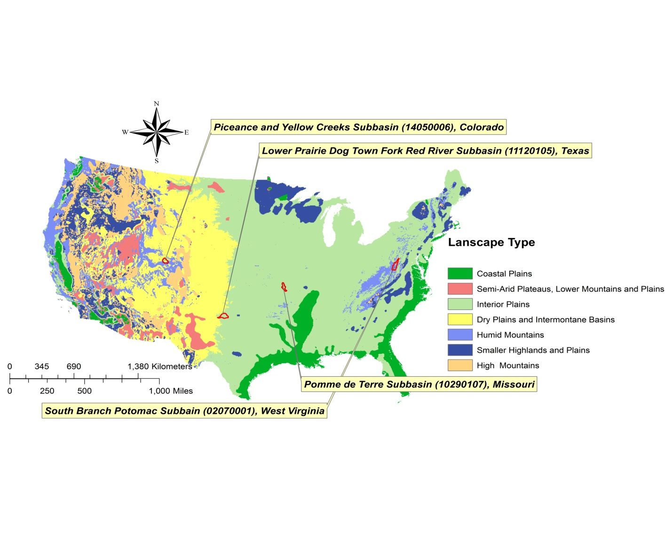

**Locations:**

The variety of locations used gives credence to a sound model for selecting density partition thresholds.  Physiographic environments vary from the exceptionally dense crenulated formations that would seem to have uncountable first order streams in a more precipitous region, to regions that are very precipitous but have relatively few first order streams due to a variety of factors from soil moisture content to ground cover. Note the location of these sub-basins on the map of the conterminous United States (see figure 1): the variability that is included in just these four data sets provides a sample that can be used to demonstrate the effectiveness of such a density threshold technique which would be applicable to additional sub-basins.

Figure 1

Based upon elevation data available in the description, and the utilization of Arc Spatial Analyst Slope Tool to generate slope data, The Pomme de Terre River in Missouri (see figure 2), located in a subbasin described as hilly, has an elevation range of 253.77m and a mean of 322.06m, with a standard deviation of 48.60. The slope has a mean of 7.4% and a standard deviation of 6.18m. The Lower Prairie Dog Town Fork of the Red River in Texas (see figure 3) is also in a hilly subbasin with an elevation range of 518.99m, mean of 630.24m, and standard deviation of 90.12. The area’s slope has a mean of 5.83% and a standard deviation of 7.92m.

The two areas described as mountainous, the South Branch of the Potomac in West Virginia (see figure 4) and the Piceance and Yellow Creek in Colorado (see figure 5) have elevation ranges of 1323.78m and 1332.42m. The mean for the South Branch is 667.09m with a standard deviation of 278.55m. The mean slope is 30.37%, standard deviation 19.90m. The Piceance and Yellow Creek subbasin has a mean elevation of 2202.57m with a standard deviation of 209.17m. The mean of the slope is 26.73% and the standard deviation is 20.29m.

|  |  |
| --- | --- |
| missory.jpg | texas.jpg |
| (a) | (b) |
| colorado.jpg | vriginia.jpg |
| (c) | (d) |
| Figure 2 | |

Table 2

|  |  |  |  |  |  |
| --- | --- | --- | --- | --- | --- |
| **NHD Sub-Basin Name, Location** | **Sub-Basin ID / HUC_12** | **Landscape Type** | **Physiographic** | **Elevation** | **Slope** |
| Pomme de Terre, Missouri | 10290107 | Hilly Humid | Interior Highlands  Ozark Plateaus | **Range:** 253.77m  **Mean:** 322.06m  **STD:** 48.60 | **Mean:** 7.04%  **STD:** 6.18 |
| Lower Prairie Dog Town Fork Red River, Texas | 11120105 | Hilly Dry | Interior Plains  Great Plains and Central Lowland | **Range:** 518.99m  **Mean:** 630.24m  **STD:** 90.12 | **Mean:** 5.83%  **STD:** 7.92 |
| South Branch Potomac, West Virginia | 02070001 | Mountainous Humid | Appalachian Highlands  Vallies & Ridges | **Range:** 1323.78m  **Mean:** 667.09m  **STD:** 278.55 | **Mean:** 30.37%  **STD:** 19.90 |
| Piceance and Yellow Creek Colorado | 14050006 | Mountainous Dry | Intermontane Plateaus  Colorado Plateaus | **Range:** 1333.42m  **Mean:** 2202.57m  **STD:** 209.17 | **Mean:** 26.73%  **STD:** 20.29 |

1. http://ned.usgs.gov/about.html
2. <http://ned.usgs.gov/faq.html>
3. <http://nhd.usgs.gov/nhd_faq.html>
4. <http://nhd.usgs.gov/Frequently+Asked+Questions+about+the+NHD+&+WBD.htm>
5. <http://ned.usgs.gov/highlights.html>
6. Gesch, D., Evans, G., Mauck, J., Hutchinson, J., Carswell Jr., W.J., 2009, *The National Map*—Elevation: U.S. Geological Survey Fact Sheet 2009-3053, 4 p.
7. Gesch, D.B., Oimoen, M.J., and Evans, G.A., 2014, Accuracy assessment of the U.S. Geological Survey National Elevation Dataset, and comparison with other large-area elevation datasets—SRTM and ASTER: U.S. Geological Survey Open-File Report 2014–1008, 10 p., [*http://dx.doi.org/10.3133/ofr20141008*](http://dx.doi.org/10.3133/ofr20141008).
8. <http://ned.usgs.gov/standards.html>
9. <http://www.mowin.org/pdf/hucprimer.pdf>
10. <http://www.nrcs.usda.gov/Internet/FSE_DOCUMENTS/stelprdb1042207.pdf>
11. **http://pubs.usgs.gov/tm/tm11a3/pdf/TM11-A3.pdf**

**3- Methodology**

**4-3- Validation Procedure**

**4- Evaluation and Results**

Piceance and Yellow Creek

The Piceance and Yellow Creek sub-basin, located in western Colorado, is part of the region defined as intermountain and Colorado Plateaus. This region is defined by its dry climate and mountainous terrain, with a mean elevation of 2202 m and an average slope of 26.7%. The Piceance and Yellow Creek hydrologic unit (HU) has three density partitions that are applied to the fourteen separate polygons within the sub-basin. The average CLC for the sub-basin is 74% with a standard deviation of 0.098.

Six polygons grouped by a density of 0.8558 km per km2 have an average threshold of 828.33, a standard deviation of 467.18 and threshold range of 1160. The combined area of the six polygons is 510,357,455.58 m2 with an average CLC of 69% with a standard deviation of 0.095.

Four polygons grouped by a density of 1.3542 km per km2 have an average threshold of 582.5, standard deviation of 636.21and threshold range of 1370. The combined area of the four polygons is 1,582,574,339.20 m2 with an average CLC of 80% with a standard deviation of 0.117.

Four polygons grouped by a density of 2.358 km per km2 have an average of threshold of 120, standard deviation of 40.82 and threshold range of 90. The combined area of the four polygons is 299,740,628.48 m2 with an average CLC of 75% with a standard deviation of 0.078.

Pomme de Terre, Missouri

The Pomme de Terre sub-basin, located in west central Missouri, is part of the region defined as Interior Highlands and Ozark Plateaus. This region is defined by its humid climate and hilly terrain features. The Pomme de Terre sub-basin has a mean elevation of 322 m and an average slope of 7.0%. This HU has three density partitions that are applied to the ten separate polygons within the sub-basin. The average CLC for the sub-basin is 67% with a standard deviation of 0.153.

Four polygons grouped by a density of 0.8889 km per km2 have an average threshold of 437.5, a standard deviation of 198.73 and threshold range of 410. The combined area of the four polygons is 62,481,073.35 m2 with an average CLC of 76% with a standard deviation of 0.160.

Two polygons grouped by a density of 1.449 km per km2 have an average threshold of 250, standard deviation of 56.57 and threshold range of 80. The combined area of the two polygons is 1,841,591,515 m2 with an average CLC of 60% with a standard deviation of 0.086.

Four polygons grouped by a density of 2.2604 km per km2 have an average of threshold of 127.5, standard deviation of 73.20 and threshold range of 160. The combined area of the four polygons is 330,962,888.2 m2 with an average CLC of 62% with a standard deviation of 0.152.

Lower Prairie Dog Town Fork Red River, Texas

The Lower Prairie Dog Town Fork Red River, Texas sub-basin, located in northern Texas, is part of the region defined as Interior Plains/Great Plains and Central Lowland. This region is defined by its dry climate and hilly terrain. The Lower Prairie Dog Town Fork Red River sub-basin has a mean elevation of 630 m and an average slope of 5.8%. This HU has three density partitions that are applied to the twenty-seven separate polygons within the sub-basin. The average CLC for the sub-basin is 57% with a standard deviation of 0.186.

Seven polygons grouped by a density of 0.5365 km per km2 have an average threshold of 2245.70, a standard deviation of 2126.14 and threshold range of 5160. The combined area of the seven polygons is 736,923,738.7 m2 with an average CLC of 40% with a standard deviation of 0.120.

Five polygons grouped by a density of 1.3852 km per km2 have an average threshold of 219.00, standard deviation of 68.96 and threshold range of 170. The combined area of the five polygons is 2,081,448,972 m2 with an average CLC of 57% with a standard deviation of 0.065.

Thirteen polygons grouped by a density of 2.1458 km per km2 have an average of threshold of 173.85, standard deviation of 124.80 and threshold range of 540. The combined area of the thirteen polygons is 833,911,503.3 m2 with an average CLC of 65% with a standard deviation of 0.189.

South Branch Potomac, West Virginia

The South Branch Potomac sub-basin located in north-eastern West Virginia is part of the region defined as valleys and ridges of the Appalachian Highlands. This region is defined by its humid climate and mountainous terrain. The South Branch Potomac sub-basin has a mean elevation of 667 m and average slope of 30.4%. The HU has three density partitions that are applied to the twenty-four separate polygons within the sub-basin. The average CLC for the sub-basin is 72% with a standard deviation of 0.104.

Seven polygons grouped by a density of 0.8939 km per km2 have an average threshold of 437.14, a standard deviation of 118.00 and threshold range of 350. The combined area of the seven polygons is 262,605,803.77 m2 with an average CLC of 62% with a standard deviation of 0.140.

Two polygons grouped by a density of 1.4011 km per km2 have an average threshold of 355, standard deviation of 213.93 and threshold range of 50. The combined area of the two polygons is 2,764,300,148.23 m2 with an average CLC of 74% with a standard deviation of 0.063.

Thirteen polygons grouped by a density of 2.2156 km per km2 have an average of threshold of 245, standard deviation of 41.23 and threshold range of 160. The combined area of the thirteen polygons is 824,410,270.22 m2 with an average CLC of 76% with a standard deviation of 0.047.

|  |
| --- |
|  |
|  |

|  |  |  |  |  |
| --- | --- | --- | --- | --- |
| **ID** | **area** | **DENSITY** | **Threshold** | **CLC** |
| 1 | 15155054.47 | 2.3580 | 150 | 0.8120 |
| 2 | 15675689.52 | 1.3542 | 160 | 0.8432 |
| 3 | 137611473.15 | 2.3580 | 130 | 0.7810 |
| 4 | 67658747.60 | 2.3580 | 140 | 0.7638 |
| 5 | 16622862.49 | 0.8558 | 450 | 0.5363 |
| 6 | 17174973.99 | 1.3542 | 330 | 0.6866 |
| 7 | 41486046.33 | 0.8558 | 530 | 0.7353 |
| 8 | 15737310.26 | 1.3542 | 1530 | 0.9488 |
| 9 | 195523471.87 | 0.8558 | 660 | 0.7178 |
| 10 | 19817600.28 | 0.8558 | 1610 | 0.6828 |
| 11 | 79315353.26 | 2.3580 | 60 | 0.6341 |
| 12 | 212989444.79 | 0.8558 | 1190 | 0.8187 |
| 13 | 23918029.82 | 0.8558 | 530 | 0.6496 |
| 14 | 1533986365.43 | 1.3542 | 310 | 0.7325 |

|  |  |  |  |  |
| --- | --- | --- | --- | --- |
|  | **CLC** | **Threshold** | **Elevation** | **Slope** |
| Max | 0.948808 | 1610 |  |  |
| Min | 0.536252 | 60 |  |  |
| Mean | 0.738749 | 555.7142857 | 2202.57 | 26.73% |
| STD | 0.098363 | 501.336988 | 209.17 | 20.29 |

|  |
| --- |
|  |
|  |
|  |
|  |
|  |
|  |
|  |

|  |
| --- |
|  |
|  |

|  |  |  |  |  |
| --- | --- | --- | --- | --- |
| **ID** | **area** | **DENSITY** | **Threshold** | **CLC** |
| 1 | 217894952.91 | 1.4490 | 210.0000 | 0.5442 |
| 2 | 187313905.20 | 2.2604 | 130.0000 | 0.6890 |
| 3 | 22252037.78 | 2.2604 | 70.0000 | 0.5051 |
| 4 | 91853498.88 | 2.2604 | 80.0000 | 0.4737 |
| 5 | 866407.52 | 0.8889 | 270.0000 | 0.9584 |
| 6 | 17329868.36 | 0.8889 | 680.0000 | 0.7324 |
| 7 | 25609642.12 | 0.8889 | 280.0000 | 0.5739 |
| 8 | 18675155.35 | 0.8889 | 520.0000 | 0.8045 |
| 9 | 29543446.29 | 2.2604 | 230.0000 | 0.7939 |
| 10 | 1623696561.99 | 1.4490 | 290.0000 | 0.6663 |

|  |  |  |  |  |
| --- | --- | --- | --- | --- |
| **Column1** | **CLC** | **Threshold** | **Elevation** | **Slope** |
| Max | 0.473746 | 70 |  |  |
| Min | 0.958419 | 680 |  |  |
| Mean | 0.674156 | 276 | 322.06 | 7.04% |
| STD | 0.15329 | 191.9606441 | 48.6 | 6.18 |

|  |
| --- |
|  |
|  |
|  |
|  |
|  |
|  |
|  |

|  |
| --- |
|  |
|  |

|  |  |  |  |  |
| --- | --- | --- | --- | --- |
| **ID** | **Area** | **Density** | **Threshold** | **CLC** |
| 1 | 21845437.89 | 1.3852 | 240 | 0.5378 |
| 2 | 4560015.19 | 1.3852 | 190 | 0.5221 |
| 3 | 22284460.84 | 2.1458 | 140 | 0.7947 |
| 4 | 150343957.56 | 2.1458 | 170 | 0.7534 |
| 5 | 16016638.69 | 2.1458 | 190 | 0.8330 |
| 6 | 42190502.31 | 2.1458 | 190 | 0.7526 |
| 7 | 53946238.50 | 2.1458 | 120 | 0.7193 |
| 9 | 19140216.30 | 2.1458 | 110 | 0.7480 |
| 10 | 22689823.10 | 0.5365 | 430 | 0.4981 |
| 11 | 20693477.79 | 0.5365 | 740 | 0.4745 |
| 12 | 22842338.62 | 2.1458 | 210 | 0.3762 |
| 13 | 36069262.74 | 0.5365 | 640 | 0.4394 |
| 14 | 329352583.49 | 0.5365 | 4880 | 0.2935 |
| 15 | 5826471.62 | 2.1458 | 0 | 0.5677 |
| 16 | 151906155.79 | 0.5365 | 2110 | 0.4101 |
| 17 | 15436688.89 | 2.1458 | 540 | 0.2567 |
| 18 | 128884498.80 | 0.5365 | 5590 | 0.1772 |
| 19 | 47395227.07 | 1.3852 | 330 | 0.5237 |
| 20 | 69003541.03 | 2.1458 | 100 | 0.4068 |
| 21 | 47327936.95 | 0.5365 | 1330 | 0.4963 |
| 22 | 18685601.66 | 1.3852 | 160 | 0.5896 |
| 23 | 16464281.77 | 2.1458 | 230 | 0.8095 |
| 25 | 293927195.57 | 2.1458 | 140 | 0.7064 |
| 26 | 106488974.63 | 2.1458 | 120 | 0.7673 |
| 27 | 1988962689.86 | 1.3852 | 175 | 0.6744 |

|  |  |  |  |  |
| --- | --- | --- | --- | --- |
| **Column1** | **CLC** | **Threshold** | **Elevation** | **Slope** |
| Min | 0.17721 | 0 |  |  |
| Max | 0.833024 | 5590 |  |  |
| Mean | 0.565125 | 763 | 630.24 | 5.83 |
| STD | 0.185644 | 1424.634456 | 90.12 | 7.92 |

|  |
| --- |
|  |
|  |
|  |
|  |
|  |
|  |
|  |

|  |
| --- |
|  |
|  |

|  |  |  |  |  |
| --- | --- | --- | --- | --- |
| **ID** | **Area** | **Density** | **Threshold** | **CLC** |
| 1 | 23980499.80 | 2.2156 | 200 | 0.7747 |
| 2 | 24940589.95 | 2.2156 | 240 | 0.7198 |
| 3 | 32354862.41 | 2.2156 | 300 | 0.7514 |
| 4 | 49036753.26 | 2.2156 | 240 | 0.6943 |
| 6 | 18366292.62 | 2.2156 | 200 | 0.7141 |
| 7 | 41976648.93 | 0.8939 | 480 | 0.7504 |
| 8 | 25649443.62 | 0.8939 | 410 | 0.6217 |
| 9 | 18887771.17 | 2.2156 | 280 | 0.8281 |
| 10 | 38931973.57 | 2.2156 | 160 | 0.7565 |
| 11 | 15210743.52 | 0.8939 | 400 | 0.6615 |
| 12 | 42899608.90 | 2.2156 | 190 | 0.8171 |
| 13 | 164194251.97 | 2.2156 | 160 | 0.6649 |
| 14 | 89287517.99 | 0.8939 | 450 | 0.6952 |
| 15 | 92932031.40 | 2.2156 | 180 | 0.7631 |
| 16 | 22101781.31 | 2.2156 | 150 | 0.7920 |
| 17 | 18783444.47 | 1.4011 | 300 | 0.7890 |
| 18 | 35494383.96 | 0.8939 | 330 | 0.7525 |
| 20 | 30022013.43 | 0.8939 | 320 | 0.5316 |
| 21 | 252627146.12 | 2.2156 | 140 | 0.7502 |
| 22 | 43156707.74 | 2.2156 | 160 | 0.7908 |
| 23 | 24965052.32 | 0.8939 | 670 | 0.3617 |
| 24 | 2745516703.76 | 1.4011 | 250 | 0.6998 |

|  |  |  |  |  |
| --- | --- | --- | --- | --- |
| **Column1** | **CLC** | **Threshold** | **Elevation** | **Slope** |
| Min | 0.361716 | 140 |  |  |
| Max | 0.828064 | 670 |  |  |
| Mean | 0.712749 | 282.2727273 | 667.09 | 30.37% |
| STD | 0.103898 | 133.056802 | 278.55 | 19.9 |

|  |
| --- |
|  |
|  |
|  |
|  |
|  |
|  |
|  |

|  |
| --- |
|  |
|  |

|  |  |  |
| --- | --- | --- |
| **ID** | **Threshold** | **CLC** |
| 1 | 420 | 0.7610 |
| 2 | 320 | 0.5255 |
| 3 | 70 | 0.6049 |
| 4 | 240 | 0.7430 |
| 5 | 300 | 0.7258 |
| 6 | 290 | 0.7782 |
| 7 | 720 | 0.6559 |
| 8 | 270 | 0.7516 |
| 9 | 330 | 0.7009 |
| 10 | 900 | 0.5847 |
| 11 | 560 | 0.7662 |
| 12 | 570 | 0.7163 |
| 13 | 460 | 0.7857 |
| 14 | 420 | 0.9055 |
| 15 | 380 | 0.6606 |
| 16 | 590 | 0.6886 |
| 17 | 590 | 0.7680 |
| 18 | 850 | 0.7408 |
| 19 | 140 | 0.7755 |
| 20 | 430 | 0.6902 |
| 21 | 150 | 0.7577 |
| 22 | 480 | 0.8023 |
| 23 | 380 | 0.8068 |
| 24 | 300 | 0.8131 |
| 25 | 360 | 0.7062 |
| 26 | 470 | 0.6507 |
| 27 | 200 | 0.8099 |
| 28 | 140 | 0.7799 |
| 29 | 150 | 0.8167 |

|  |  |  |
| --- | --- | --- |
| **Column1** | **CLC** | **Threshold** |
| Min | 0.5255 | 395.862069 |
| Max | 0.9055 | 70 |
| Mean | 0.7335 | 900 |
| STD | 0.079658 | 206.5968683 |